# **Format for uploading details in GitHub and Slack in word file format**

**Student Name: Shrinivasa**

**Class and Sec: VI B**

**USN: 4AL17CS092**

|  |  |  |  |  |
| --- | --- | --- | --- | --- |
| **Online Test Details** | | | | |
| **Subject** |  | | | |
| **Semester** | **VI - B** | | **Duration** | **Minutes** |
|  | |  | | |

**Encl: snapshot of the test result**

|  |  |  |  |
| --- | --- | --- | --- |
| **Pre-Placement Training Summary** | | | |
| **Pre placement training** | **9:00 am to 11:00 am – Java (Exception Handling)** | | |
| **Faculty** | **Mr. Sharan Pais** | **Duration** | **2 hours** |

**Encl: snapshots of the daily class activities**

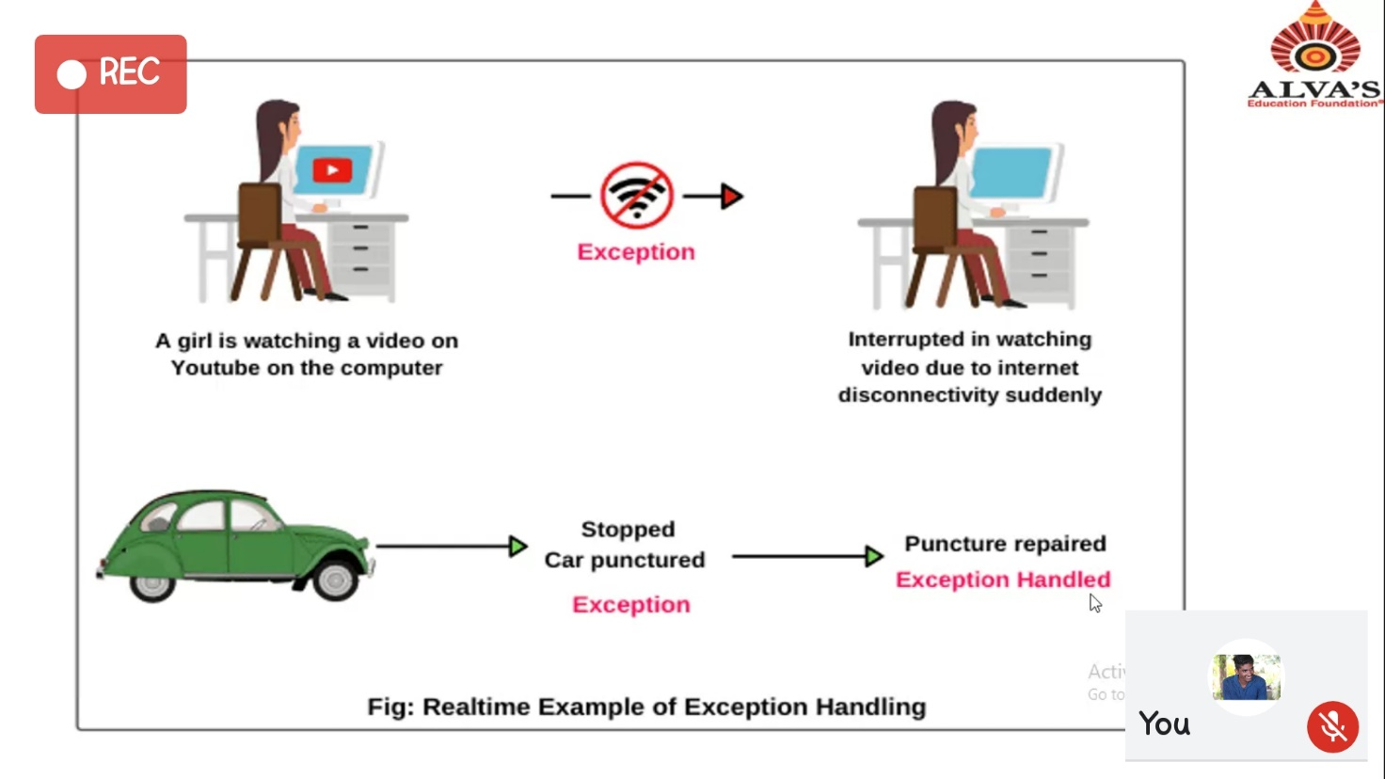

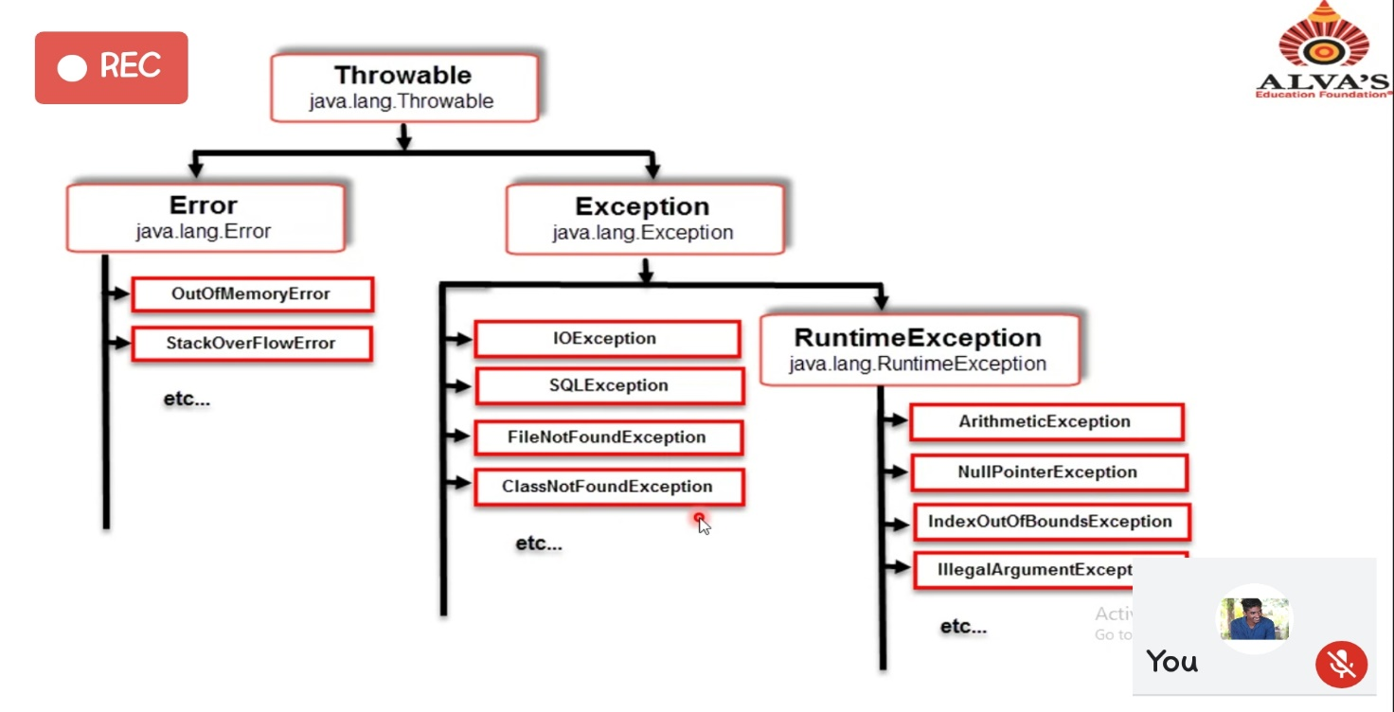

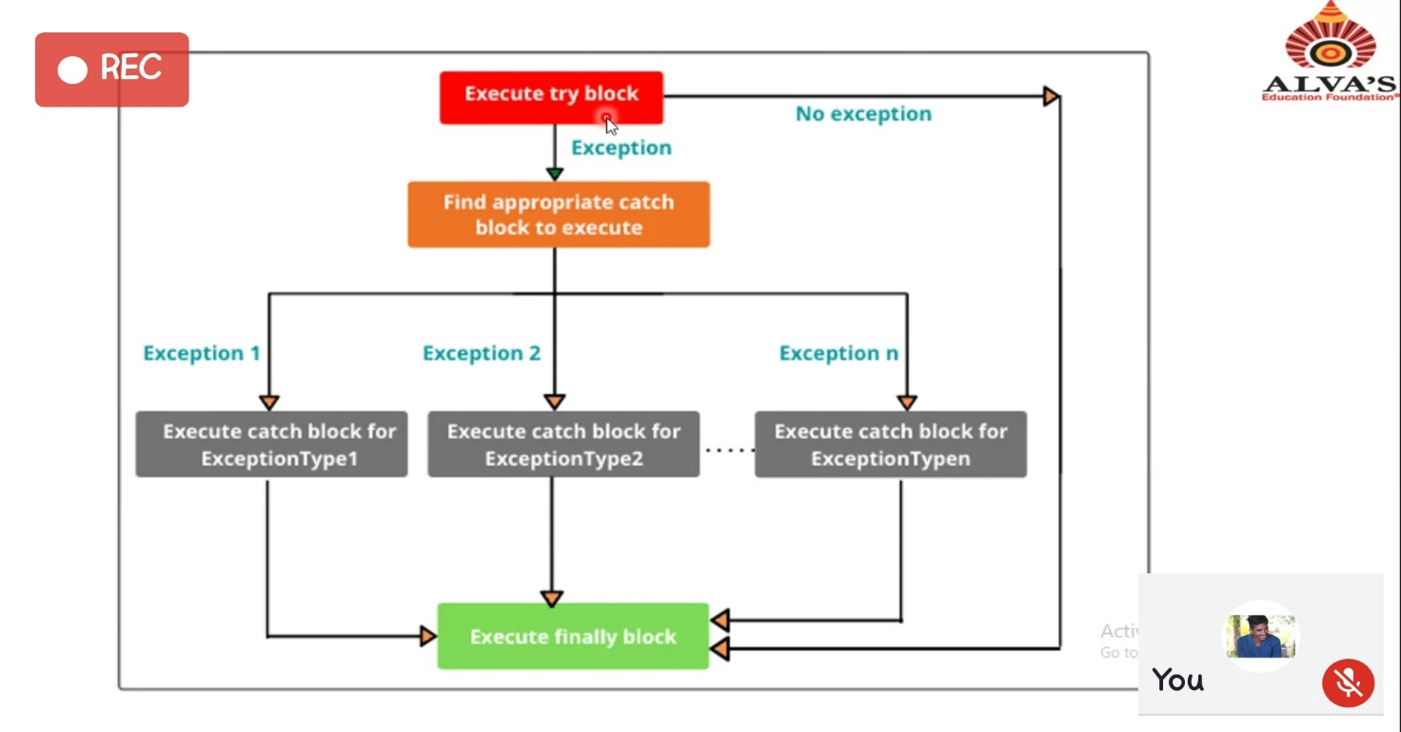

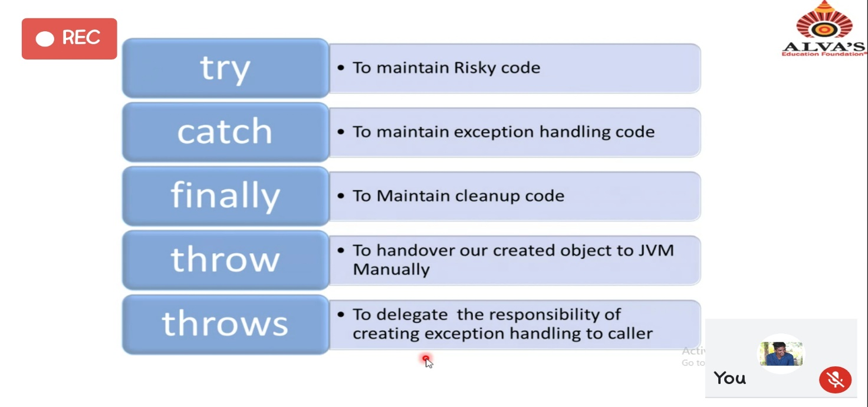

|  |  |
| --- | --- |
| **Coding Challenges** | |
| **Problem Statement:**  [**https://github.com/Shrinivasakunder/certification-and-online-coding**](https://github.com/Shrinivasakunder/certification-and-online-coding) | |
| **Status: -** | |
| **Uploaded the report both in GitHub & Slack** | - |

**Encl: snapshots of your response to challenge.**